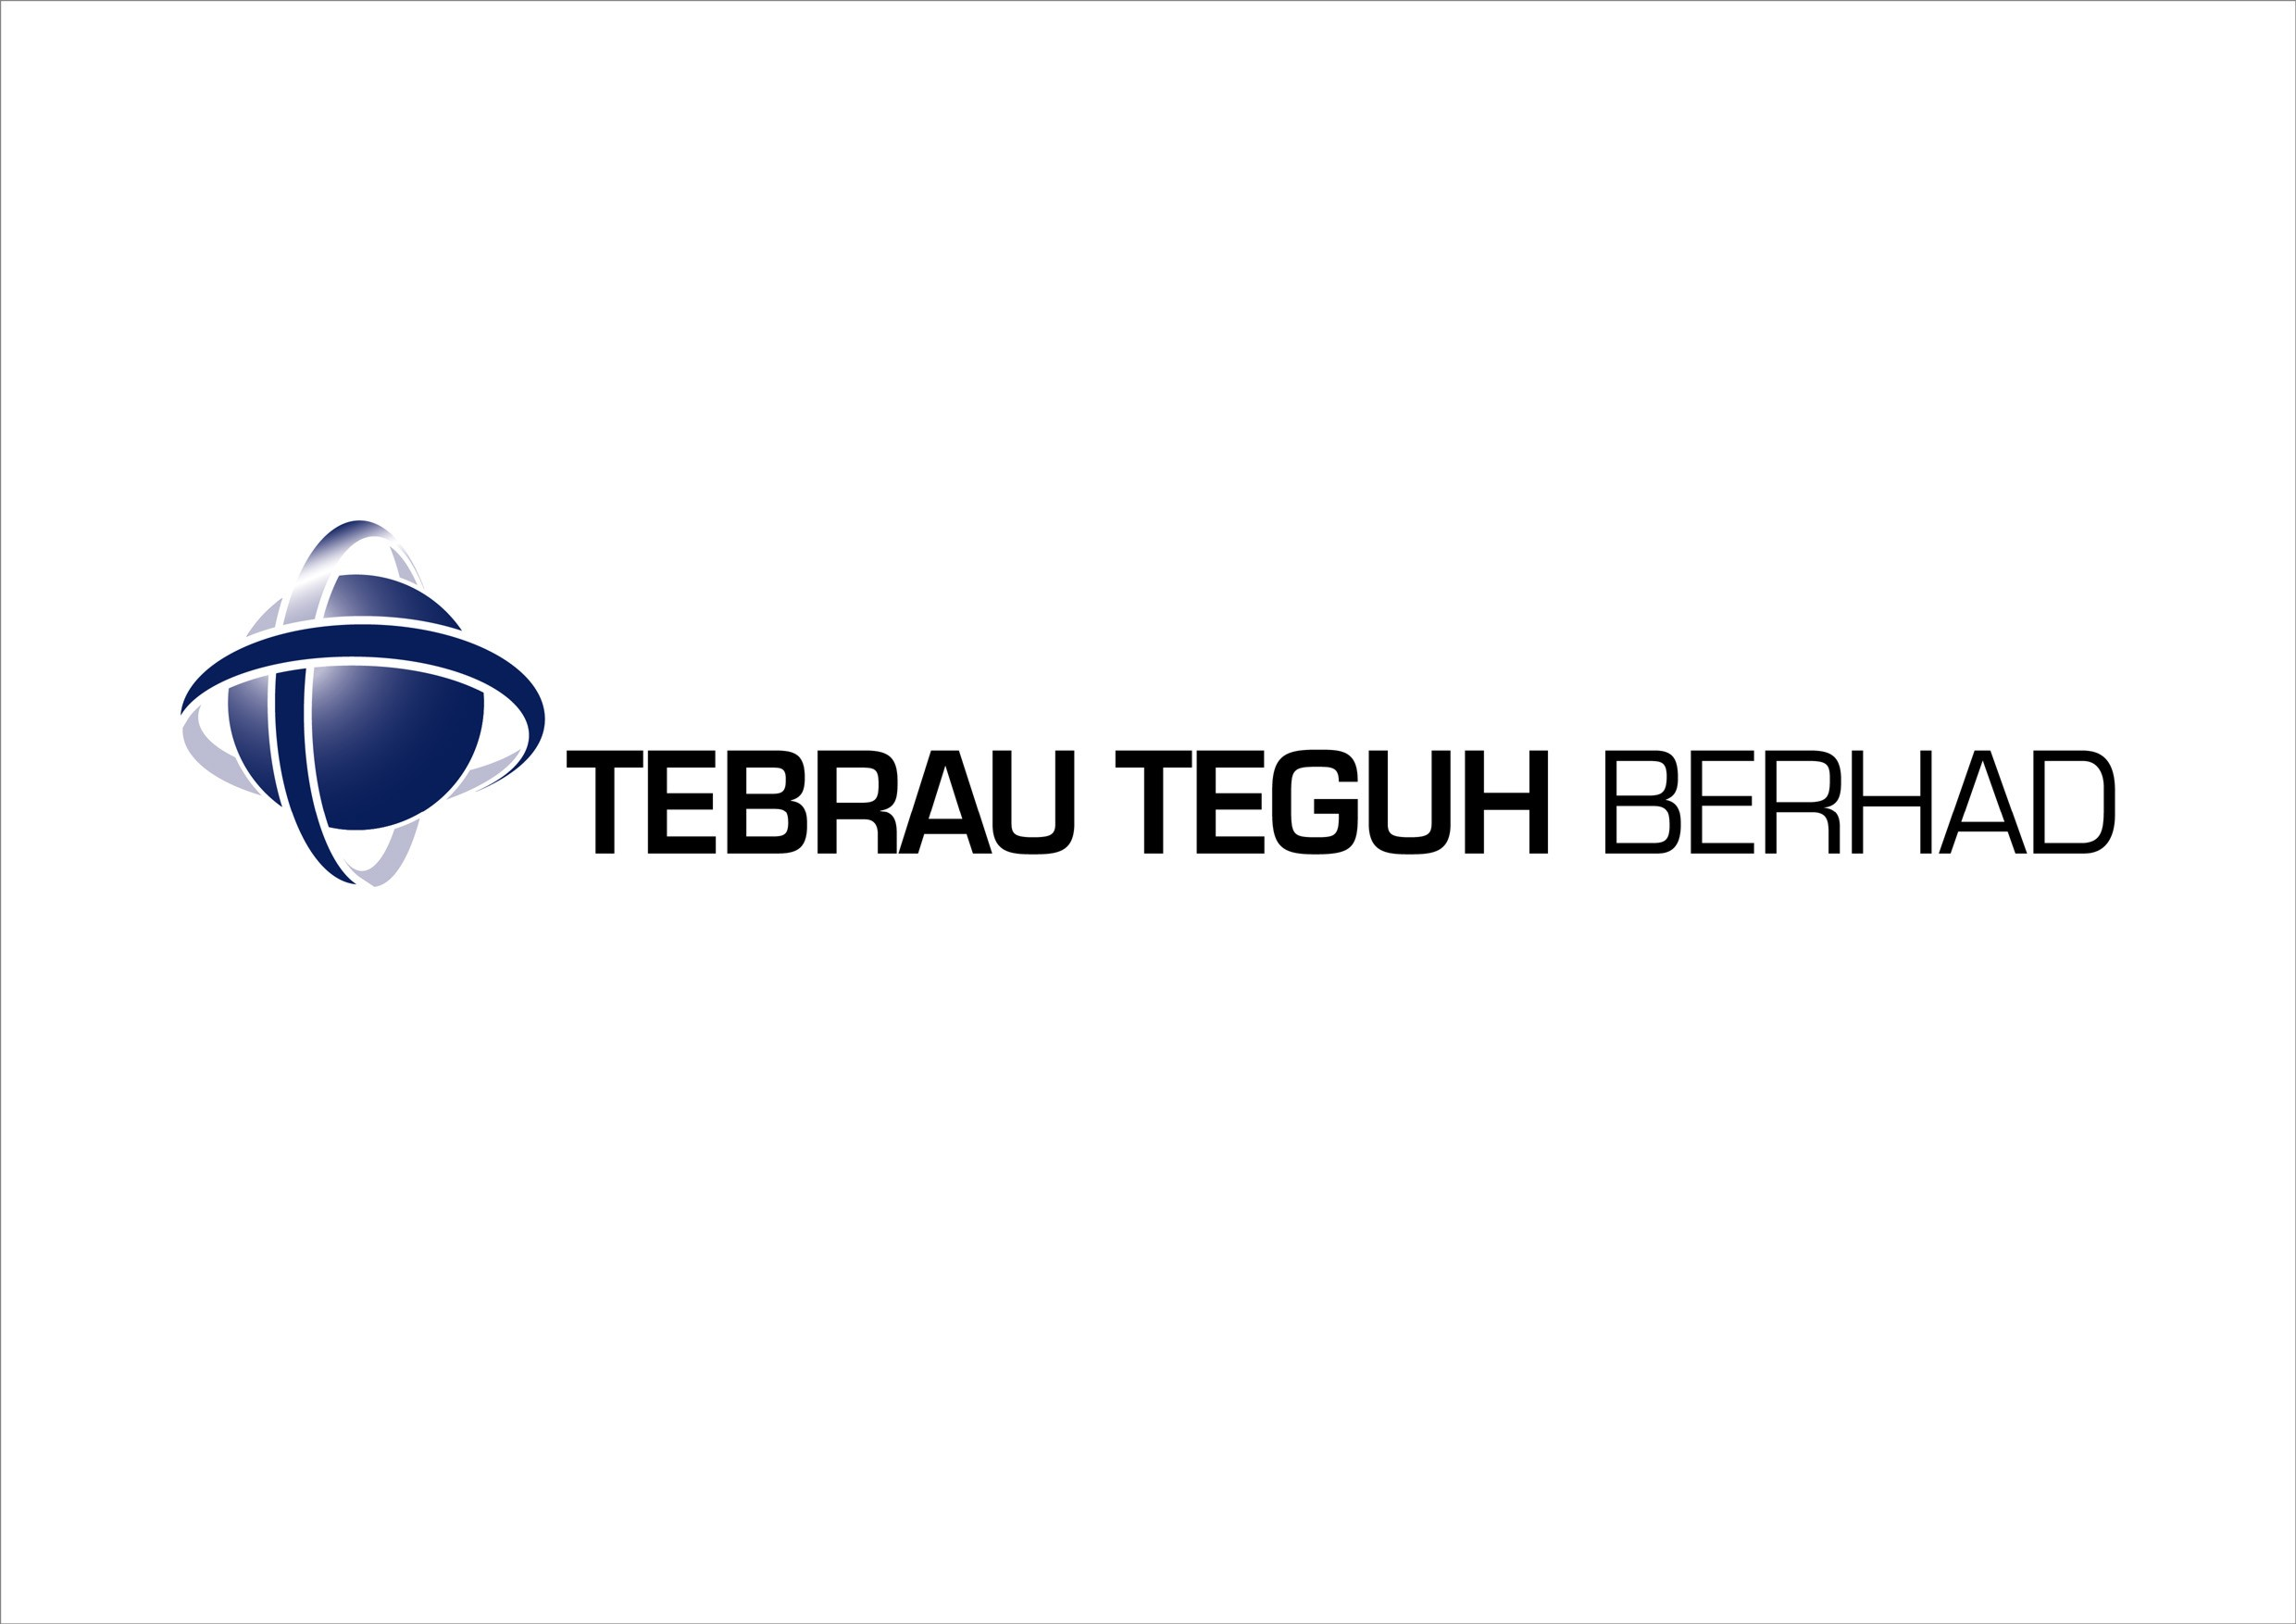

INTERIM FINANCIAL STATEMENTS
FOR THE FINANCIAL PERIOD ENDED 31 MAR 2005

CONDENSED CONSOLIDATED INCOME STATEMENTS

 | INDIVIDUAL QUARTER |  | CUMULATIVE QUARTER
 | Current quarter  31.03.05 | Previous year corresponding quarter  31.03.04 | 3 months ended  31.03.05 | 3 months ended  31.03.04
 | RM’000 | RM’000 | RM’000 | RM’000
Revenue | 2,570 | 17,188 | 2,570 | 17,188
Other operating income | 28 | 8 | 28 | 8
Operating expenses | (3,810) | (17,530) | (3,810) | (17,530)
Profit/(Loss) from operations | (1,212) | (334) | (1,212) | (334)
Finance costs | (4) | (231) | (4) | (231)
Share of results of associated companies | - | - | - | -
Profit/(Loss) before taxation | (1,216) | (565) | (1,216) | (565)
Taxation | 34 | (155) | 34 | (155)
Profit/(Loss) after taxation | (1,182) | (720) | (1,182) | (720)
Minority interest | - | - | - | -
Net profit/(loss) for the period | (1,182) | (720) | (1,182) | (720)

EARNINGS/(LOSS) PER SHARE
Basic (sen) | (0.18) | (0.11) | (0.18) | (0.11)
Diluted (sen) | N/A | N/A | N/A | N/A

The Condensed Consolidated Income Statement should be read in conjunction with the annual audited financial statements for the year ended 31 December 2004.

CONDENSED CONSOLIDATED BALANCE SHEETS

 | Unaudited as at  31.03.05  RM’000 |  | Audited as at  31.12.04  RM’000
NON-CURRENT ASSETS
Property, plant and machinery | 4,669 |  | 4,803
Investments in associated companies | 2,322 |  | 2,322
Investment properties | 1,602 |  | 1,602
Other investments | 90 |  | 90
Land held for future development | 189,035 |  | 189,035
Deferred tax assets | 58 |  | 58
 | 197,776 |  | 197,910
CURRENT ASSETS
Development properties | 407,946 |  | 409,737
Inventories | 657 |  | 1,094
Trade receivables | 34,530 |  | 42,205
Other receivables | 24,377 |  | 26,495
Cash and bank balances | 13,297 |  | 9,434
 | 480,807 |  | 488,965
CURRENT LIABILITIES
Trade payables | 44,834 |  | 41,053
Other payables | 3,959 |  | 11,605
Borrowings | 3,006 |  | 6,199
Tax payable | 118 |  | 118
 | 51,917 |  | 58,975
NET CURRENT ASSETS | 428,890 |  | 429,990
 | 626,666 |  | 627,900
FINANCED BY:
Share capital | 334,864 |  | 334,864
Reserves | 136,716 |  | 137,899
Shareholders’ equity | 471,580 |  | 472,763
NON-CURRENT LIABILITIES
Borrowings | 14,945 |  | 14,963
Deferred taxation | 140,141 |  | 140,174
 | 626,666 |  | 627,900
Net tangible assets per share (RM) | 0.70 |  | 0.71

The Condensed Consolidated Balance Sheets should be read in conjunction with the annual audited financial statements for the year ended 31 December 2004.
CONDENSED CONSOLIDATED STATEMENT OF CHANGES IN EQUITY

 | Share capital  RM’000 | Share premium  RM’000 | Exchange fluctuation reserve  RM’000 | Accumulated losses  RM’000 | Total  RM’000
At 1 January 2004 | 334,864 | 528,127 |  | (363,429) | 499,562
Issue of share capital | - | - | - | - | -
Net Loss for the year | - | - | - | (26,799) | (26,799)
Accumulated losses written off against share premium account | - | (302,306) | - | 302,306 | -
At 31 December 2004 | 334,864 | 225,821 | - | (87,922) | 472,763
At 1 January 2005 | 334,864 | 225,821 | - | (87,922) | 472,763
Net loss for the period | - | - | - | (1,183) | (1,183)
At 31 March 2005 | 334,864 | 225,821 | - | (89,105) | 471,580

The Condensed Consolidated Statements of Changes in Equity should be read in conjunction with the annual audited financial statements for the year ended 31 December 2004.
CONDENSED CONSOLIDATED CASH FLOW STATEMENTS

 | 3 months ended 31.03.05  RM’000 |  | 3 months ended  31.03.04  RM’000
Net cash generated from/(used in) operating activities | 7,278 |  | (1,624)
Net cash generated from/(used in) investing activities | 25 |  | (22)
Net cash generated from/(used in) financing activities | (3,440) |  | 667
Net increase/(decrease) in cash and cash equivalents | 3,863 |  | (979)
Cash and cash equivalents at beginning of year | 9,434 |  | 10,416
Cash and cash equivalents at the end of quarter | 13,297 |  | 9,437
Cash and cash equivalents comprise:
Cash and bank balances | 13,142 |  | 9,347
Deposit with licensed banks | 155 |  | 90
 | 13,297 |  | 9,437

The Condensed Consolidated Cash Flow Statements should be read in conjunction with the annual audited financial statements for the year ended 31 December 2004.

INTRODUCTION

The interim financial statements of Tebrau Teguh Berhad (“the Company” or “TTB”) and of the Group are unaudited and have been prepared under the historical cost convention and in accordance with the requirement of FRS 134 : Interim Financial Reporting and Paragraph 9.22 of the Listing Requirements of Bursa Malaysia Securities Berhad.

The interim financial statements should be read in conjunction with the Group’s audited financial statements for the year ended 31 December 2004. The accounting policies, method of computation and basis of consolidation adopted for the interim financial statements are applied consistent with the property and development industry, the Companies Act 1965 and the Approved Accounting Standards.

AUDITORS’ REPORT OF THE PRECEDING FINANCIAL YEAR ENDED 31 DECEMBER 2004

The Auditors’ Report of the financial statements of the Company and of the Group for the year ended 31 December 2004 was not subject to any qualification.

SEASONAL OR CYCLICAL FACTORS

The Group’s business operations are not seasonal but cyclical in nature, which is dependent on the economic conditions in Malaysia.

UNUSUAL ITEMS

There were no unusual items affecting assets, liabilities, equity, net income, or cash flows during the financial period under review because of their nature, size, or incidence.

CHANGES IN ESTIMATES

There were no changes in estimates of amounts reported in previous quarters of the current financial year or changes in estimates of amounts reported in prior financial years that have had a material effect in the current quarter.

DEBTS AND EQUITY SECURITIES

There were no issuances and repayment of debts and equity securities, share buy-backs, share cancellations, shares held as treasury shares and resale of treasury shares during the financial period ended 31 March 2005.

DIVIDENDS

No dividends are recommended, have been declared, or have been paid during the financial quarter ended 31 March 2005.

VALUATION OR PROPERTY, PLANT AND EQUIPMENT

The valuations of property, plant and equipment have been brought forward without amendment from the audited financial statements for the year ended 31 December 2004.

MATERIAL EVENTS SUBSEQUENT TO THE END OF THE INTERIM PERIOD

There were no material events subsequent to the end of the current quarter that have not been reflected in the quarterly financial statements.

GROUP COMPOSITION

There were no material changes in the composition of the Group during the financial quarter under review.

CHANGES IN CONTINGENT LIABILITIES OR CONTINGENT ASSETS

Contingent liabilities of the Group comprise the following:

 | 31.03.05 | 31.12.04
 | RM’000 | RM’000
Corporate guarantees given by the Company for facilities granted to a subsidiary | 6,567 | 6,567
Performance bond issued by subsidiaries involved in construction activities | 5,524 | 5,524

SEGMENTAL REPORTING

Analysis by Activities
 | Turnover  Year To Date |  | Profit/Loss before  Taxation  Year To Date
 | 31.03.05  RM’000 | 31.03.04  RM’000 | 31.03.05  RM’000 | 31.03.04  RM’000
Property development | 2,361 | 7,145 | 34 | 1,664
Construction | 245 | 10,583 | (618) | (1,200)
Property Management | 232 | - | 125 | -
 | 2,838 | 17,728 | (459) | 464
Share of results of associated company | - | - | - | -
Consolidation adjustment | (268) | (541) | (319) | (170)
 | 2,570 | 17,188 | (778) | 295
Unallocated corporate expenses | - | - | (434) | (629)
Interest expense | - | - | (4) | (230)
 | 2,570 | 17,188 | (1,216) | (565)

No segmental reporting on geographical location is prepared as the Group’s activities are carried out in Malaysia.

REVIEW OF PERFORMANCE

(i) Comparison with the previous corresponding quarter and financial period

The lower turnover for the current quarter ended 31 March 2005 compared to the previous corresponding quarter ended 31 March 2004 was mainly due to the lower sale of houses as a result of the soft property market condition and lower construction billings as a result of existing contracts nearing completion. Also, the turnover from construction contract under Jabatan Perumahan Negara is only expected to be recognised in the next quarter. However, the property management activities have started generating revenue for the first quarter.

The loss after taxation of the Group in the current quarter ended 31 March 2005 was mainly due to lower turnover from the group business activities.

(ii) Comparison with the preceding quarter

The lower turnover for the current quarter as compared to the preceding quarter was mainly due to lower revenue from the construction and property development activities

As provision for the actual and foreseeable losses on the construction contracts that have been completed and nearing completion have been fully recognised in previous quarter, the loss after taxation for the first quarter has been improved.

PROSPECTS

The Group’s performance for the current financial year is expected to be moderate.

For property development, the Group is focusing on selling and completing the existing projects. New projects are being developed and expected to be launched in this year.

In addition, Jabatan Perumahan Negara has awarded Tebrau Bay Sdn. Bhd., a wholly-owned subsidiary of the Company with a construction contract valued at RM83.75 million in October 2004 for the design, build and completion of 1,500 units of low cost flats in Taman Sri Stulang, Johor Bahru. The contribution from this contract will commence from 2nd quarter 2005. The Group will remain focus on completing the existing construction contracts and provision of maintenance work on contracts under defect liability period.

The Group continues to seek new opportunities for its core businesses i.e. property development and construction to further expand its future earnings.

PROFIT FORECAST

The Group has not provided any profit forecast in a public document.

TAXATION

Income tax expense | Current year quarter  31.03.2005  RM’000 | 3 months cumulative to date  31.03.2005  RM’000
Malaysian Income Tax
- previous year
- current year
Transfer to/(from) deferred taxation | (34) | (34)
 | (34) | (34)

UNQUOTED INVESTMENTS AND PROPERTIES

There were no purchases or sales of unquoted investments and properties for the current quarter and financial year to date.

QUOTED INVESTMENTS

There were no purchases or sale of quoted securities for the current quarter and financial year to date.

There were no investments in quoted securities as at the end of the current quarter.

STATUS OF CORPORATE PROPOSALS

The status of corporate exercise announced but not completed is set out below.

The proposed capitalisation and issuance of 4,999,998 new ordinary shares of RM1.00 each in Langkawi Airport Hotel Sdn Bhd (“LAH”), a wholly owned subsidiary of the Company (“Proposed Capitalisation”) has been approved by the shareholders of the Company on 30 December 2003. The completion of the Proposed Capitalisation remains pending the necessary approvals needed to be obtained by Ekran Berhad, the proposed subscriber of the new shares in LAH to be issued.

BORROWING AND DEBT EQUITIES

Details of the Group’s borrowings as at 31 March 2005 are as follows:

 | Current |  | Non current
 | RM’000 |  | RM’000
Bridging loans (secured)* | 2,809 |  | 14,303
Hire purchase liabilities | 197 |  | 642
Total | 3,006 |  | 14,945

As at 31 March 2005, RM23.1 million was drawdown from the total facilities of RM35 million bridging loan under the Principle of Bai’bithaman Ajil with Bank Kerjasama Rakyat Malaysia Bhd. Approximately RM5.99 million has been repaid through the redemption from sale of development properties products. From the outstanding loan, RM2.81 million is due within this year whilst the balance of RM14.3 million will be payable within year 2006 to 2008.

OFF BALANCE SHEET FINANCIAL INSTRUMENTS

There were no off-balance sheet financial instruments.

MATERIAL LITIGATION

 | Case No./Parties | Remarks and status
1 | Kuala Lumpur High Court No.  D7-22-2202-01  Gerak Reka Akitek Sdn Bhd vs GIB | This case is in relation to a claim for professional fees on work done in respect of a proposed condominium and townhouse project on Lots 1852 and 1853, Mukim Ampang, Kuala Lumpur, amounting to RM400,000 plus costs.  On 12 April 2005 the Court has dismissed the Plaintiff’s claim with costs.
2 | Kuala Lumpur High Court No.  D7-22-1299-99  GIB vs Malayan Banking Berhad (“MBB”) | This case is in relation to the claim of RM2,674,828.83 plus costs and interest against MBB.  The matter has been fixed for Trial on 20, 21, 27, 28 and 29 June 2005.
3 | Johor Bahru High Court No.  24-2894-2003(4)  Tebrau Bay Sdn Bhd (“TBSB”) vs United Victoria Sdn Bhd (“UVSB”) and Kong Sun Enterprise Sdn Bhd (“KSE”) | This legal case is in relation to a claim of RM12.6 million by TBSB, a wholly owned subsidiary of the Company, against the Defendants in respect of the sale of 51% equity interest in Asset Nusantara Development Sdn Bhd to the Defendants.  The case has been fixed for mention on 22 June 2005.
4 | Johor Bahru High Court O/Summons  No. MT1-24-2736-2004  Tebrau Teguh Berhad (“TTB”) vs MDSB Sdn. Bhd. (“MDSB”) | This case is in relation to a claim of RM25m by the Company against MDSB in respect of the balance of the purchase price of RM25m which was due on 15 October 2003 pursuant to the Deed of Sale cum Trust Deed dated 26 April 2002 (as supplemented by a Supplemental Deed of Sale cum Turst Deed dated 15 April 2003).  The Company is currently in negotiation with MDSB and therefore has requested for the case to be postponed with a right to file afresh. However, the Court has struck out the application.

The above legal case nos. 1 and 2 are the continuing responsibility of Diamond League Sdn Bhd (“DLSB”) pursuant to the Deed of Sale cum Trust Deed dated 26 April 2002 entered into between DLSB and the Company. Since the cases have been taken up under the Company’s name, it is therefore prudent to make the necessary provisions. Full provision of potential liabilities has been made in the financial statements for item 1 and 3. The outcome of the legal cases will not have any effect on the financial position of the Company.

EARNINGS AND LOSS PER SHARE

The basic earnings/ (loss) per share for the financial period has been calculated based on the Group’s earnings/(loss) after taxation and dividend by the 669,727,143 ordinary shares of RM0.50 each in issue during the financial period. There have been no dividends paid in the current period to date and in the prior year.

